Joint PronSIG / GISIG event October 14th 10.00 – 17.00
Africa Centre, 66 Great Suffolk Street, London, SE1 0BL
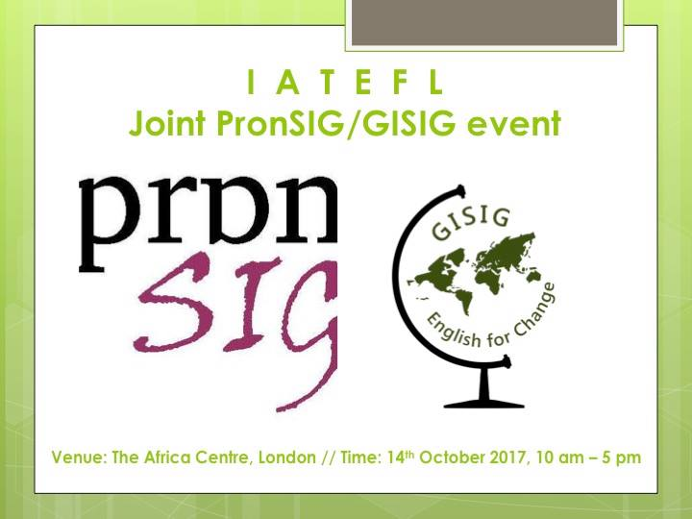
‘Globunciation: exploring the interface between pronunciation and global issues’
10 – 10.10 Welcome and introduction: GISIG and PronSIG coordinators
10.10 – 10.40 Mark Hancock - Pronunciation for iconoclasts
Abstract: Pronunciation teaching is sometimes held back by an unhelpful insistence on the phonetic detail of target models. Some features, such as the schwa for example, seem to almost acquire the status of icons. What happens if we
knock these icons off their pedestals?
Bio: Mark Hancock started teaching English in 1984. He's worked in Spain, Turkey,
Brazil and the UK. He has published many pronunciation books, including
Pronunciation Games (CUP 1995), English Pronunciation in Use Intermediate
(CUP 2012) and PronPack 1-4 (Hancock McDonald ELT 2017)

10.45 – 11.15 Aleks Palanac - Positive Psychology in ELT for Refugees
Abstract: As concepts such as "mindfulness" and "positive emotionality" gain currency in many spheres of today's society, it has become pertinent to ask how such tenets of "positive psychology" might be applied to enhance ELT (including L2 pronunciation), particularly in relation to the teaching of vulnerable learners such as refugees.
Biodata: Over the past 13 years, Aleks Palanac has been an ELT teacher, examiner and resources developer. She now works as an EAP Tutor at the University of Leicester, currently teaching on a range of courses, including EAP provision for refugees. Her special interests include positive psychology, identity and learner autonomy.

11.15 – 11.30 – coffee break
11.30 – 12.30 - Professor Jennifer Jenkins, Chair of Global Englishes and Director of the Centre for Global Englishes in Modern Languages at the University of Southampton
What, why, and whence English as a Lingua Franca?
Abstract: The phenomenon of English as a Lingua Franca (ELF) has become well established within ELT over the past 25 years. The earliest research into ELF focused on forms, particularly pronunciation. Later the attention turned to ELF’s functions and processes, and most recently to the implications of its inherent multilingualism. Along the way, ELF has attracted growing support as well as detractors, including within IATEFL. In this talk, I will explore ELF from its beginnings to the present day, and consider its future, not least in light of Brexit.
Biodata: Jennifer Jenkins is professor of Global Englishes and director of the Centre for Global Englishes at the University of Southampton. She has been researching English as a Lingua Franca for nearly 30 years and published three monographs on the subject: The Phonology of English as an International Language (OUP 2000), English as a Lingua Franca: Attitude and Identity (OUP 2007), and English as a Lingua Franca in the International University. The Politics of Academic English Language Policy (Routledge 2014). She is also the author of a university coursebook, Global Englishes (Routledge 2015, 3rd edition).

12.35 – 13.05 Laura Patsko: How to help learners understand the world's accents
Abstract: The use of English as an international lingua franca means learners need to understand a wide variety of accents, both native and non-native. How can teachers prepare them for such diversity? In this practical workshop we'll demo a 5-step lesson plan, informed by the latest research into ELF and pronunciation.

Biodata: Laura Patsko is a researcher and teacher trainer, specialising in the use of English as an international lingua franca, teaching pronunciation and investigating the practical applications of linguistic research. She currently works for a major ELT publisher. She also blogs at laurapatsko.wordpress.com and elfpron.wordpress.com, and tweets as @lauraahaha and @ELF_pron.

13.05 – 13.50 lunch
13.50 – 14.20 Gergő Fekete - Nature is speaking – it’s time to listen!
Abstract: “The environment”: a coursebook unit, a topic in language exams, but more importantly, a significant global issue. This workshop aims to turn nature into a motivating and thought-provoking topic by introducing a powerful video series and a choice of creative tasks that cover both receptive and productive aspects of phonology.
Biodata: Gergő is a teacher of English and German in Hungary and also the Social Media Coordinator of IATEFL’s GISIG. After studying in the U.S. and Germany and completing an M.A. in Hungary, he threw himself into full-time teaching in Budapest and is looking forward to making the best use of his recently completed CELTA to teach in other countries, too.
14.25 – 14.55 James Quartley - Incorporating GI in Business English
Abstract: The traditional view of Business English is often of topics like success, marketing, finance and language skills such as negotiation, brainstorming, cold-calling. There is no single area of life that Global Issues do not directly affect, so why do so few coursebooks incorporate them? The talk will try to suggest ways to incorporate GI in Business English, based around my experiences using Market Leader (Upper Int. 3rd Edition), which is the set course book at my university in Ulm, Germany. Market Leader is also [un]fairly light on sound and pronunciation work, so I will describe three exercises I use to assist students' stress, speech patterns and pronunciation - using the course book.
Bio: I moved with my family to Germany in 2007. I have been teaching at the University of Ulm for the last 8 years, mainly Business English with Economics and Management students. Before working at the university full time, I was training employees in many local businesses and companies.
15.00 – 15.30 Rose Aylett - PC or not PC? THAT is the question
Abstract: The election of a self-styled ‘straight-talking’ American president has led to the re-emergence of the debate surrounding politically correct language. How can we address this culturally-sensitive issue in class without endorsing ‘political correctness gone mad’? This presentation will explore the challenges surrounding the topic and offer some practical classroom solutions.
Biodata: Rose Aylett is a freelance teacher trainer and Celta tutor, based in Liverpool. She has been working in ELT for over ten years, predominantly across North Africa and the Middle East. Her research interests include materials-light teaching, creativity in teacher education and the integration of global issues into the classroom.
15.30 – 15.45 tea break
15.45 – 16.45 Steve Brown – The Emancipation Continuum: A Framework for Evaluating the Societal Impact of ELT Practice
Abstract: We tend to evaluate ELT using very narrow criteria, rarely considering the wider impact of our practice - on learners, their social environment and the whole reason we’re teaching them English in the first place. This talk offers a framework for evaluating ELT in terms of its emancipatory potential.
Bio: Steve Brown has been working in English Language Teaching since 1993. He spent two years as a volunteer in Mongolia, followed by several years with IH in various locations. He returned to Scotland in 2001 to complete a Masters in Applied Linguistics, before finding work in the further education sector.
Besides teaching, Steve has worked in a number of management and training roles. He is currently Curriculum and Quality Leader for the Languages department at West College Scotland, just outside Glasgow, and also hopes to complete his Doctorate of Education at the University of Glasgow.
16.45 – 17.00 Julietta Schoenmann / Linda Ruas: Questions and Discussion

