Sustainable Development Goals in English classes or English clubs – ideas:
What are the SDGs (Sustainable Development Goals)?
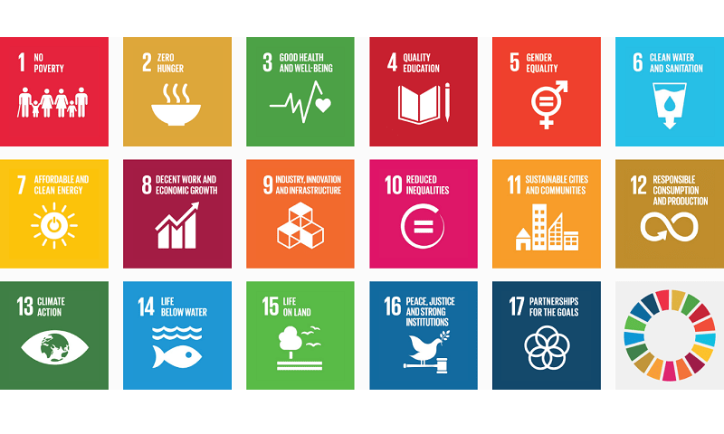
Find our more here – click on each goal to read more: https://sustainabledevelopment.un.org/sdgs
Here are some ideas of activities to do in class to get learners involved. If you’re teaching learners in Africa, why not enter (by 30th June) some of their best work in our GISIG/YLTSIG ‘Voices from Africa’ competition – more information here: http://gisig.iatefl.org/competitions/voices-from-africa-competition
New language: You know the level of language of your class, so you will need to decide if you need to teach them relevant vocabulary (ie. the topics of the SDGs) and grammar (eg. modal verbs: we must/should/need to/could work on …..; conditionals: if we work on x, it will …..) before each of these tasks or not
Research: You know your class and your teaching context – if your learners have access to a library or the internet, they could use those resources to research – otherwise, they can discuss and imagine
Feedback: You know your class and how they learn best – you can give some feedback on errors after learners’ presentations or after they have written a first draft, or get learners to correct each other
Timing: You know your class and level, so you need to decide on the timing for each stage
Class activities:
1/ Dictate, discuss, present, write:
a) Dictate the brief titles for all 17 SDGs to the class
b) Learners, in small groups, discuss the SDGs and decide what we need to do to achieve each goal, locally and globally
c) Each group presents their best suggestion(s) to the class
d) Small groups, or pairs, choose one suggestion, and write about it
2/ Research, present, rank for importance, write:
- Give out one SDG to each small group of learners to research – this can be for homework – to find out what their SDG is about and what we need to do to achieve it – both locally and globally
- Groups present their ideas to the class, others make notes and then decide, in their groups, the order of importance of the 17 goals, both locally and globally
- Each group writes a paragraph about the goal / suggestions that they think is most important
3/ Explore one SDG in depth – whole class decide on and share problems and solutions:
- Select one important SDG (or ask learners to select) for the whole class to work on eg. 5: Gender Equality, 6: Clean water and sanitation, 13: Climate action, 16: Peace, justice and strong institutions
- Each small group decides on 3 problems (local or global) and writes these on a piece of paper
- Pass the papers on to the next group, who then discuss and decide on possible solutions to the 3 problems
- Pass the paper on a different group, who then tick what they agree is the best solution and add one more solution to the problems
- Pass the papers back to the group who wrote the problems and they decide which solutions they think are best
- They then write a paragraph about how we can carry out the best suggestions and achieve the solutions to the problems
4/ ‘I have a dream’ writing task
- Read aloud to the class some of Martin Luther King’s ‘I have a dream’ speech
- Learners, in pairs, discuss what King’s dream was and if they think his dream has been achieved
- Ask learners to think about a dream they have for the world – and ask some to tell their dream to the class (eg. it could be about the environment, about gender, about plastic use, about peace etc.)
- Learners, alone or in pairs / small groups, write an ‘I have a dream’ speech of their own
- Get learners to practise reading aloud their speech, or learn it by heart, then get some to deliver their speech to the class
5/ ‘Autobiography of a ……..’ writing task
- Tell the class a story / autobiography of something small that’s everywhere in the modern world eg. a drop of water, a little piece of paper or plastic, a strand of cotton, or a drop of pesticide, starting: ‘Hello, I’m a xxxxxxxxxxxxxxxxxxx and I started life in xxxxxxxxxxxxxxxxx …..’
- They then choose something to write an autobiography of and, in pairs or small groups, write their story
- They can read out their autobiographies and decide which is the most imaginative or most true

The last 2 tasks are from the British Council book ‘Integrating Global Issues in the Creative Language Classroom’, available free here with many other classroom activities that relate to the SDGs: https://englishagenda.britishcouncil.org/continuing-professional-development/teacher-educator-framework/demonstrating-effective-teaching-behaviour/integrating-global-issues-creative-english-language-classroom

